samlogo_blue_pc.tif

**New Perspectives** Excel 2013

Tutorial 2: SAM Project 1a

Spring Software

FORMATTING A WORKSHEET

Project Goal

M Project Name

Project Goal

# PROJECT DESCRIPTION

Callie Ogawa coordinates work on the website for Spring Software, a computer software company in Cambridge, Massachusetts. She has compiled data regarding the company’s website over the past year, including information on unique customer visits to the site, in a workbook. The two tables she created include counts of several technical website metrics:

* **Sites-** counts the places on the web from which visitors came
* **Kbytes-** totals the amount of data transferred to users
* **Visits -** estimates the number of unique visits to the site
* **Pages -** indicates the number of times web pages on the site were accessed
* **Files -** counts the number of times data of any kind was sent to a user in response to a request
* **Hits -** enumerates the total requests for data.

She would like you to finish formatting her worksheet before she presents it to other members of her team.

# GETTING STARTED

* Download the following file from the SAM website:
  + **NP\_Excel2013\_T2\_P1a\_*FirstLastName*\_1.xlsx**
* Open the file you just downloaded and save it with the name:
  + **NP\_Excel2013\_T2\_P1a\_*FirstLastName*\_2.xlsx**
  + *Hint:* If you do not see the **.xlsx** file extension in the Save file dialog box, do not type it. Excel will add the file extension for you automatically.
* With the file **NP\_Excel2013\_T2\_P1a\_*FirstLastName*\_2.xlsx** still open, ensure that your first and last name is displayed in cell B6 of the Documentation sheet. If cell B6 does not display your name, delete the file and download a new copy from the SAM website.

# PROJECT STEPS

1. Change the theme of the worksheet to **Ion**.
2. On the *Website Visitors Report* worksheet, apply the Title cell style to the merged range **A1:H1** and then apply **bold** formatting to the range.
3. **Merge and center** the range **A2:H2** and then change the font size of the merged range to **14 pt**.
4. **Merge and center** the range **A3:H3**.
5. Italicize the contents of the range **A3:H3** and change the font size to **12 pt**.
6. Format the range **A7:A18** using the **Short Date** (like 3/13/2016) number format.
7. Apply the **Accent1** cell style (1st column, 4th row in the Themed Cell Styles section of the Cell Style palette) to the range **A6:H6**.
8. **Center** and apply **bold** formatting to the range **A6:H6**.
9. In cell **B19**, create a formula using the **SUM** function that totals the range **B7:B18.** Copy the formula you created in cell **B19** into the range **C19:F19**.
10. Apply the **Number** number format to the range **B7:G19** and then format the range to display commas as thousands separators and to display no decimals.
11. Apply the **Percentage** number format (with no decimal places) to the range **H7:H18**.
12. Change the background color for the range **A19:G19** to **Standard Light Green** (5th column, 1st row in the Standard Colors Palette), and then change the background color for cell H19 to **White, Background 1** (1st column, 1st row in the Theme Colors Palette).
13. Change the font color for cell G19 to **Standard Dark Red** (1st column, 1st row in the Standard Colors Palette).
14. Apply the **All Borders** cell border style to the range **A19:H19**.
15. Use the Quick Analysis tool to apply a conditional formatting rule to the range **E23:E34**. The conditional formatting rule should identify cells with a value **greater than 420** and format those cells with **Light Red Fill with Dark Red Text.**
16. Change the orientation of the worksheet to **Landscape**.
17. Change the margins for the Website Visitors Report worksheet to **Wide**.
18. Set rows 1 - 3 as print titles. (*Tip:* Rows 1 - 3 should repeat at the top of each printed page of the worksheet.)
19. In the center footer section of the *Website Visitors Report* worksheet, enter the word **Page** followed by a space, a current page number followed by a space, the word **of** followed by a space, and then the total page count. Use Header & Footer Elements for the **current page number value** and **total page count value** in this footer. For example, the footer on the first page of the worksheet should display, “Page 1 of 2”.

Your workbook should look like the Final Figures on the following pages. Save your changes, close the workbook, and exit Excel. Follow the directions on the SAM website to submit your completed project.

# Final Figure: Website Visitors Report worksheet

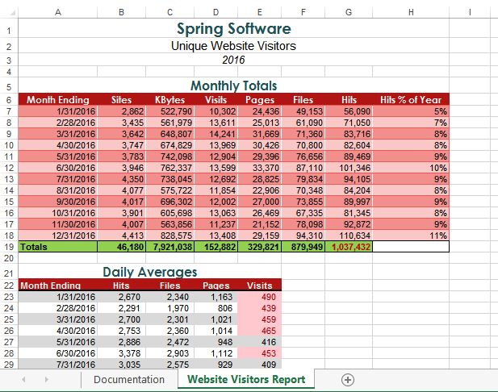

Microsoft product screenshots used with permission from Microsoft Corporation.

Copyright © 2014 Cengage Learning. All Rights Reserved.

**Final Figure 2: Print Preview**

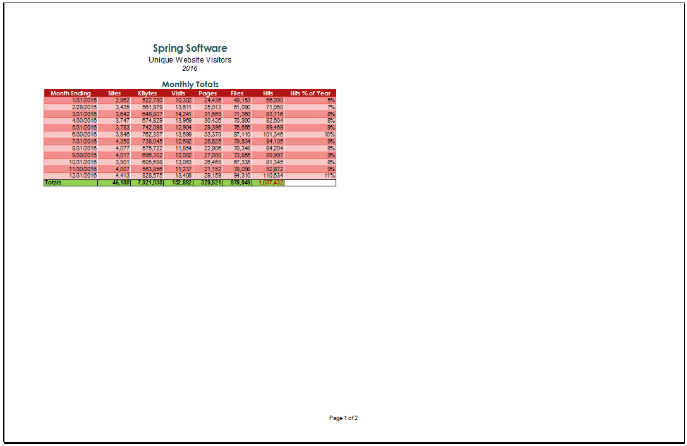

Copyright © 2014 Cengage Learning. All Rights Reserved.